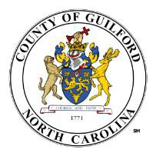

Analytics & Business Intelligence Exercise

Thank you for your interest in joining our team as an Analytics & Business Intelligence   
Consultant. You have been selected to participate in the next step in this selection process. In order for us to assess your skills in data analytics, we would like to invite you to participate in the following exercise. This exercise is designed to assess your:

- Knowledge of a data science programming language such as R or Python

- Knowledge of quantitative, qualitative, and statistical research methods

- Knowledge of data visualization techniques and best practices

- Ability to conduct and communicate data analysis in an understandable way - Ability to clean and analyze large and varied data

Interview selection will be based on the submitted results.

Instructions:

The dataset required for this exercise can be downloaded here: [Beer Reviews](https://myguilford-my.sharepoint.com/:u:/g/personal/jjones6_guilfordcountync_gov/EQwvat1TJtFGlBLyIEFS-wQB9Oy0-vOQM8FpzcW8x5aagw?e=p9LtiN)

This dataset consists of approximately 1.5 million beer reviews from Beer Advocate. Please use this dataset to answer the following questions.

1. Which brewery produces the strongest beers by ABV%?

Schorschbräu (Schorschbräu Schorschbock 57%)

2. If you had to pick 3 beers to recommend using only this data, which would you pick?

Gene’s American Brown Ale, Dos Perros, Founders Cashew Mountain Brown

3. Which of the factors (aroma, taste, appearance, palette) are most important in   
determining the overall quality of a beer?

Taste, see visual below

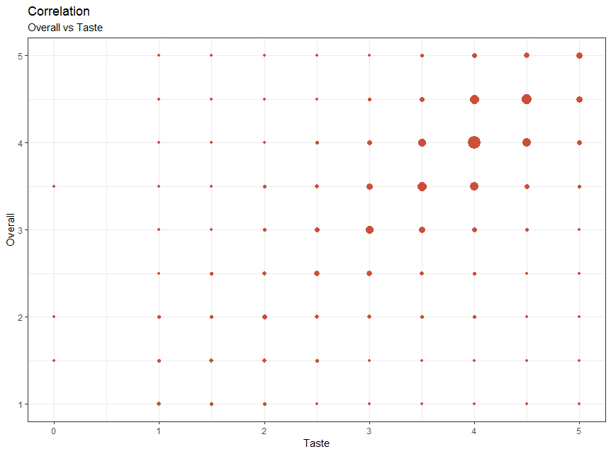

4. Lastly, if I typically enjoy a beer due to its aroma and appearance, which beer style   
should I try?

American Double / Imperial Stout

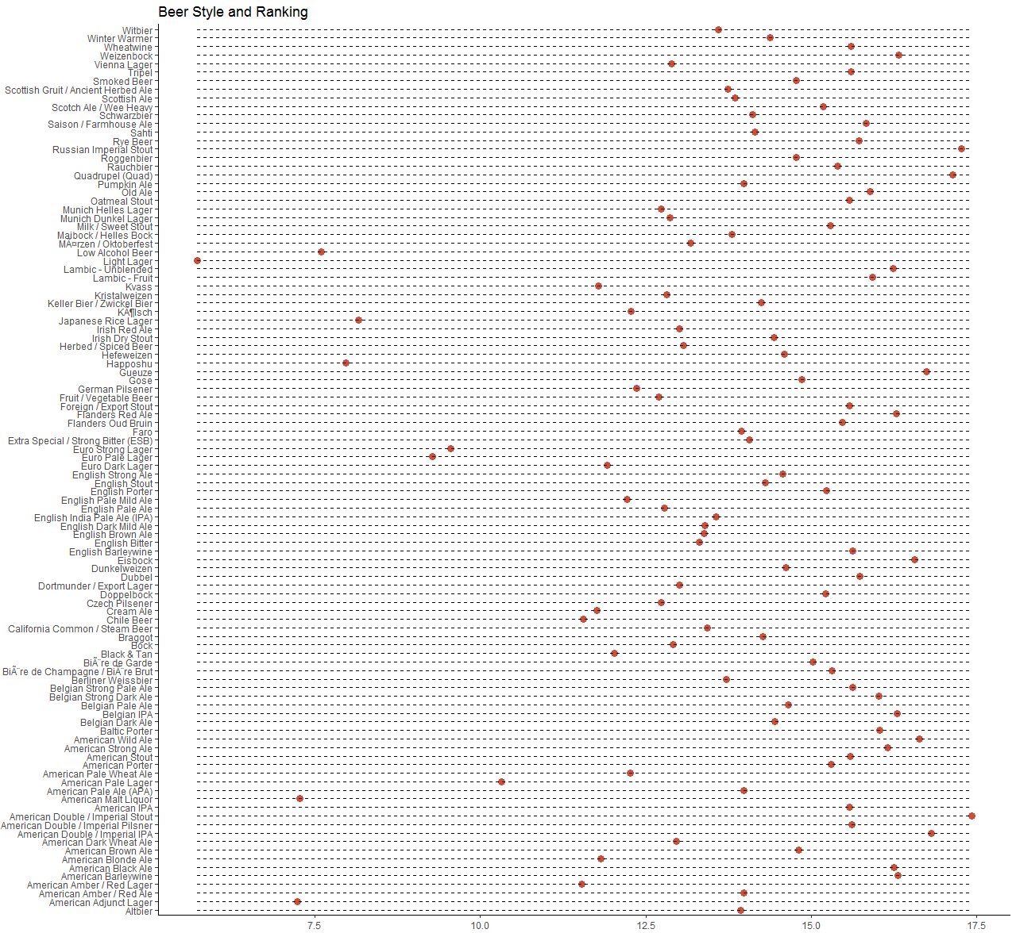

Please document your code and explain the reasoning behind your answers. I encourage you to have fun with your analysis. I also encourage you to use this time and space to demonstrate your ability to creatively design visuals. Please submit your completed assignment via a link to a   
GitHub repository.

Budget Management & Evaluation   
Guilford County, NC

Updated September 2018